Collaborative Robot Arm Control：Based on Gesture Recognition

Meet Hugo Pinard, Tsung-Ching Yang , Yi-Hung Chuang, and Peter Rubatscher, Min-Fan Ricky Lee

***Abstract*—How to control the arm with hand gestures in the traditional way is collecting data to build up the dataset and train the model with deep learning. In light of this, our research endeavors to find a new way of hand gesture recognition to control arms, which is more intuitive to the users. Therefore, this paper proposes to enhance the interaction between humans and robots, using hand gesture recognition and visual tracking. In gesture recognition and motion tracking, using the MediaPipe module to identify the hand gesture. Ultimately, our research aims to facilitate robust human-robot interaction. This, in turn, fosters an environment where the robot arm becomes a valuable and adaptable tool in addressing the needs of individuals in diverse settings.**

*Keywords—Hand Gesture Recognition, Human-Robot Interaction, Robot Manipulator, Vision Control*

# INTRODUCTION

Intelligent robotics has emerged as a prominent area of research, finding applications across various industries and domains. Among the different types of robots, robotic manipulators stand out as versatile and widely utilized devices. They are highly effective, reliable, and capable of responding quickly to various demands. Additionally, robotic arms play a significant role in reducing the risks associated with heavy, hazardous tasks, as well as assisting in medical procedures[1]. Considering these developments, there is a growing interest in developing an auxiliary operator based on a robotic manipulator to empower the elderly population.

Through the large number of pictures consisting of the dataset, training the model to recognize hand gestures. However, collecting the various kinds of hand gestures, labeling them, and training with deep learning models is quite time-consuming as well as complicated. In addition, the recognition accuracy will be influenced by light in some environment like brightness or darkness. When   it captures the gesture image in a dark environment, the image is not clear so that the recognition will be   probably not precise. Moreover, if   the hand doesn’t face the camera completely front side, some of the fingers will be hidden so that it cannot recognize the gesture accurately as well. The fingers probably bend at an ambiguous angle, and they cannot be recognized whether the fingers exactly bend or not[1], [2].

Meet Hugo Pinard is with the National Taiwan University of Science and Technology, Taipei, Taiwan (e-mail: E11212101@mail.ntust.edu.tw).

The control of robotic arms can be achieved through two primary approaches. One traditional method relies on hardware components, employing professional controllers such as teach

pendants. Alternatively, wearable gloves with flexible sensors for motion and orientation recognition have simplified the manipulation of robotic arms. However, a drawback of these hardware controls is their cost and the need for   sophisticated   sensor technology and equipment. On the other hand, computer vision technology has enabled the capture of hand gestures and tracking of their movements. This has given rise to gesture recognition algorithms, which offer a cost-effective, hardware-efficient, and highly intuitive means of commanding robotic arms[3].

# MATHODOLOGY

This conference is founded on the fundamental premise of addressing scenarios wherein elderly adults, who may contend with mobility impairments and a decline in muscle strength, find themselves in situations demanding the lifting of heavy objects. In response to these challenges, the proposal presents an innovative concept: the elderly can effectively exert direct control over a robotic arm with the use of a single hand, offering a solution that not only eases the physical burden on them but also enhances their autonomy and quality of life.

## System Architecture

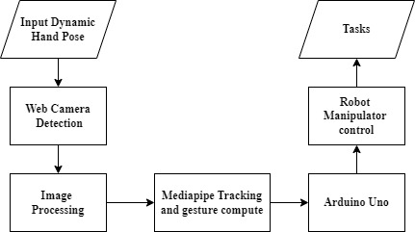

Fig. 1 Proposed System Architecture

Tsung-Ching Yang is with the National Taiwan University of Science and Technology, Taipei, Taiwan (e-mail: M11212006@mail.ntust.edu.tw).

Yi-Hung Chuang is with the National Taiwan University of Science and Technology, Taipei, Taiwan (e-mail: M11212008@mail.ntust.edu.tw).

Peter Rubatscher is with the National Taiwan University of Science and Technology, Taipei, Taiwan (e-mail: E11207002@mail.ntust.edu.tw).

Min-Fan Ricky Lee is with the National Taiwan University od Science and

Technology, Taipei, Taiwan (e-mail: rickylee@mail.ntust.edu.tw).

## Hardware

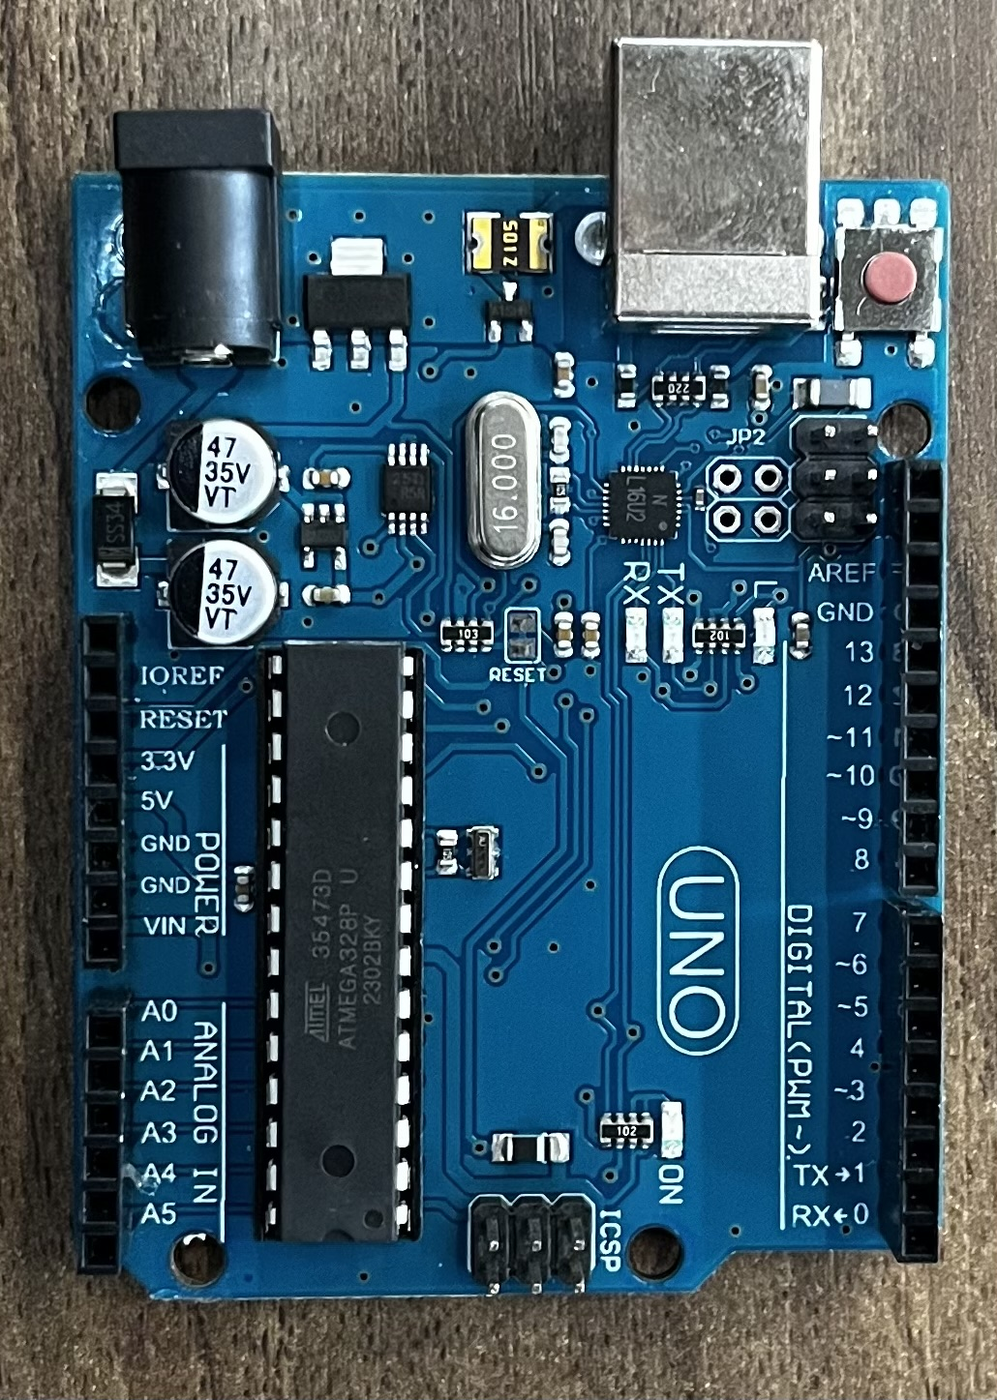

Fig. 5. Arduino Uno

### Robot Arm

**Joint 1**

**Joint** **2**

**Joint** 4

**Joint 3**

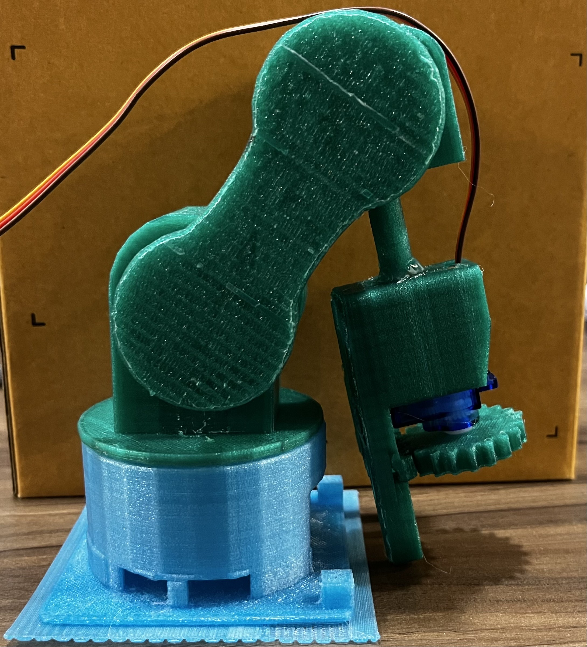

Fig. 2. Robot Manipulator

### The design of the robotic arm is based on the six degrees of freedom, with modifications and enhancements incorporated to accommodate our specific ideas.

### Circuit Diagram

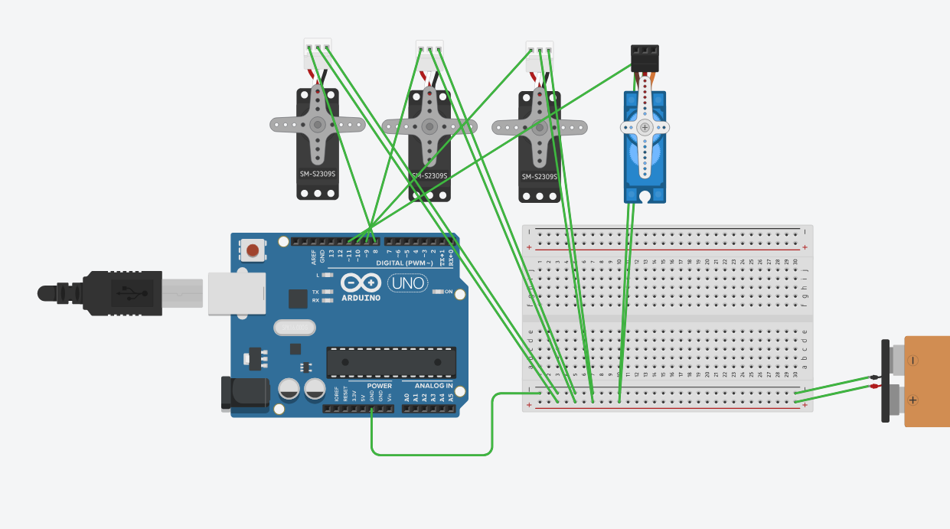

Fig. 3. Circuit

### Web *Camera*

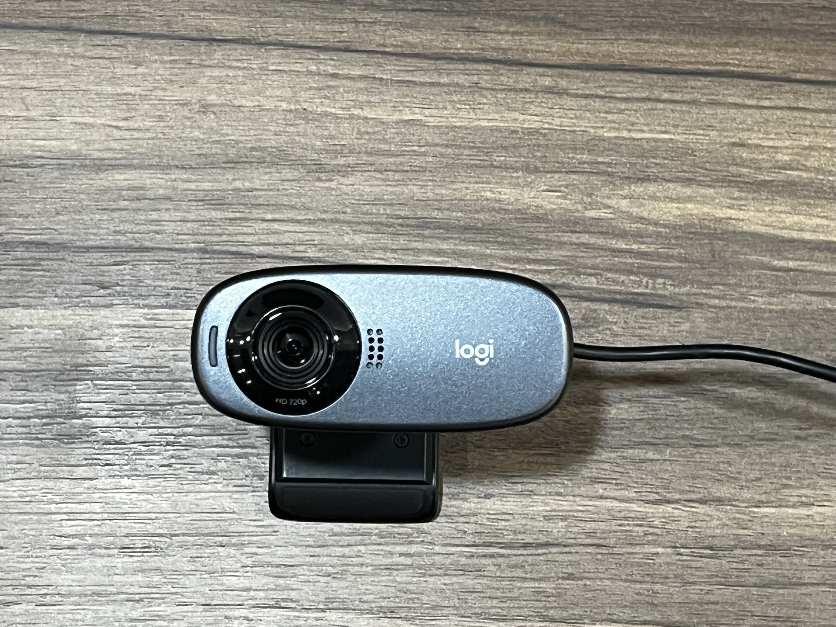

Fig. 4. Web Camera

The Web Camera is extensively employed for vision sensing tracking capabilities and recognition in our project.

### *Arduino Uno*

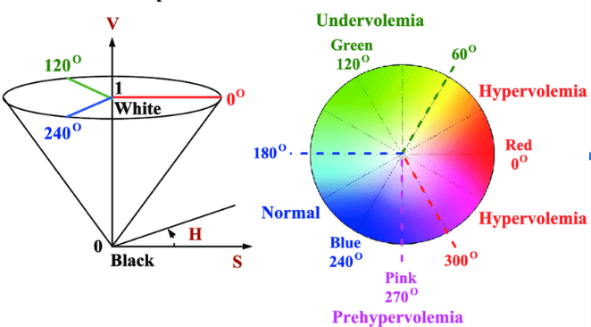

Fig. 7. HSV Color Space

The Arduino Uno microcontroller, equipped with 14 versatile digital input/output pins suitable for a wide range of applications. Furthermore, it offers 6 analog input pins for the precise reading of analog voltage levels from sensors and devices. It can be programmed to perform tasks using the open-source Arduino IDE. In the context of this project, the microcontroller is responsible for reading the serial signal from MediaPipe and subsequently controlling the servo motors.

## Image Processing

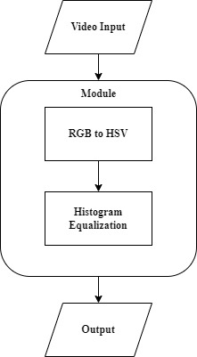

Fig.6. Image Processing Architecture

The image processing module is comprised of two integral components. Firstly, it encompasses the conversion of the RGB color space into the HSV color space, facilitating a seamless transition in color representation. Once this conversion is accomplished, the image undergoes meticulous Histogram Equalization (HE) processing, enhancing its overall visual quality and contrast. Ultimately, the module yields an impeccably refined video as its output, ready for presentation or further analysis.

### RGB to HSV

### The HSV color space, as seen in Figure 6, is depicted as a hexane and consists of three parameters: Hue (H), Saturation (S), and Value (V). Hue (H) measures color in degrees from 0° to 360°. Saturation (S) indicates how closely a color resembles a spectral hue. A color can be thought of as a mix of a spectral hue with white. Value (V) measures a color's brightness. It ranges from 0% to 100%.

The conversion to HSV color model from RGB color space is given as follows:



Normalize the value of each RGB channel:



Then, calculate the H, S, V value:







In image processing, the HSV color space is frequently used as it closely aligns with people's perceptual experience of color, more so than the RGB color space*.*

### *Histogram Equalization*

Due to computer vision techniques used for detecting and tracking hand movement and gesture changes, the process is susceptible to external lighting conditions. To address this, we employ image preprocessing through histogram equalization, which stretches the pixel intensity distribution range to enhance image contrast, improve regional contrast, and capture finer image details affected by visual recognition, influenced by external environmental lighting.

## Gesture Recognition Algorithm (MediaPipe)

### In our pursuit of hand gesture recognition for robotic control, we identified the computer vision library MediaPipe as an optimal framework. MediaPipe offers real-time hand tracking, which is essential for ensuring the robotic arm's immediate response to user gestures. Its proficiency in hand tracking is enabled by its use of machine learning, especially pre-trained models. Having been trained on comprehensive datasets focused on hand movements, these models bring the advantage of minimal computation time for highly robust and accurate hand tracking. More specifically, it employs hand landmarks detection, which can be utilized for customized gesture recognition. Its limitations are mainly shown in overlapping gestures or when the hand is partially obscured. MediaPipe, being open source, continually evolves with contributions from developers globally, ensuring our approach remains contemporary. Furthermore, its lightweight design is tailored for efficient computational use, ideal for embedded systems. After image processing, the information will be utilized through MediaPipe to detect and track hand posture and gestures. Subsequently, it will generate a skeleton of a palm with 21 landmarks, each associated with three-dimensional coordinates (x, y, z). We will use the detected palm's distance to control the Z-axis variation of the robotic arm, and employ the x and y coordinates to calculate finger bending angles. Additionally, we will establish threshold angles to control the gripper's opening and closing. Finally, the information will be transmitted via serial communication to an Arduino Uno for motor control of the robotic arm.

# Result

For Gesture Recognition control, we leverage the Mediapipe landmarks to precisely calculate the distance between specific points on the index finger, enabling us to determine the optimal angle for controlling the servo motor. Due to the motor’s angle limitation. We set boundary for each motors. There are four parts for control：

### X-axis

In configuring the X-axis, we establish a boundary spanning from 0 to 360 degrees. By utilizing the wrist landmark in conjunction with the landmarks on the index finger, we intricately compute the palm size. Subsequently, we calculate the radians formed between the wrist and the index finger, seamlessly converting these radians into degrees. This final degree measurement, ranging from 0 to 360, is then mapped to precisely control the orientation of the first joint.

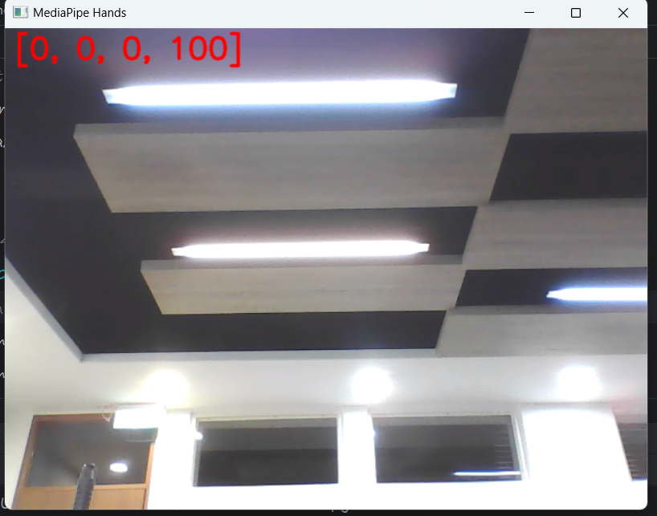

Fig. 8. Initial input

### Y-axis

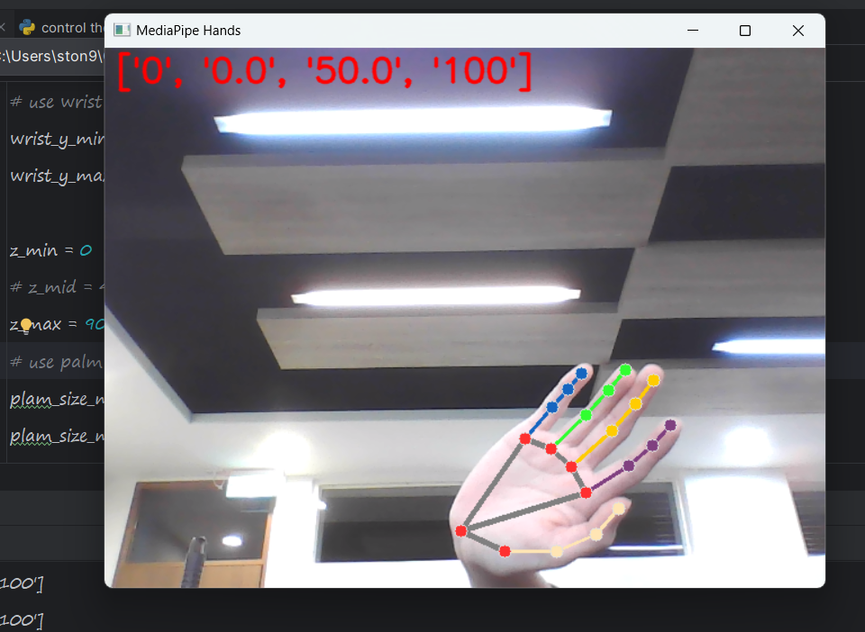

Fig. 10. Lower boundary for x-axis

In our application, we utilize the Y-component of the landmarks on the wrist to control the motion along the Y-axis (joint 2). Then, map to 0 to 90 degrees for second motor output.

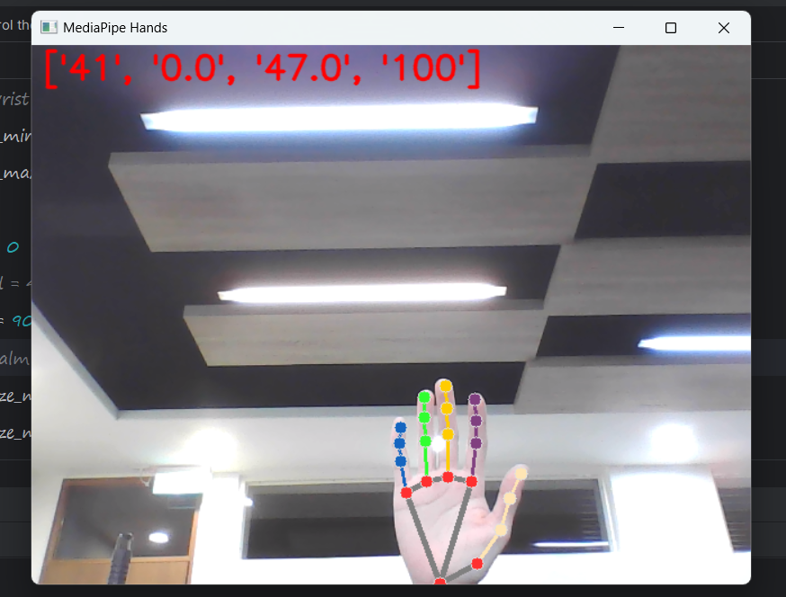

Fig. 12. Lower boundary for y-axis

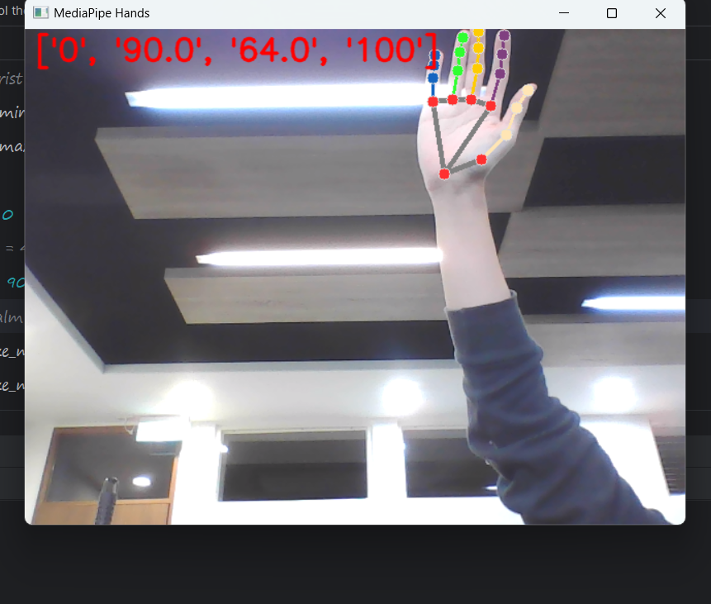

Fig. 11. upper boundary for y-axis

### Z-axis

we utilize the palm size of to control the motion along the z-axis (joint 3). Then, map to 0 to 90 degrees for third motor output.

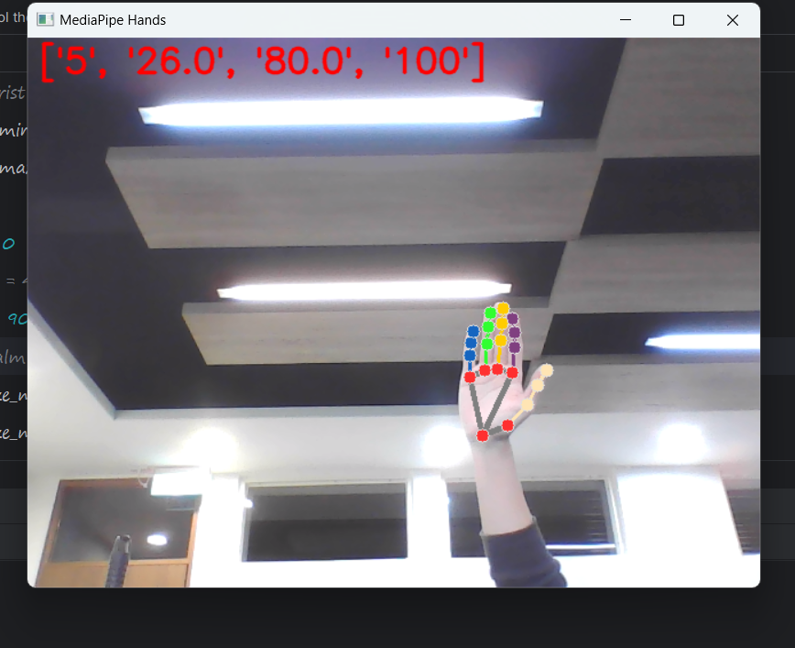

Fig. 13. Upper boundary for z-axis

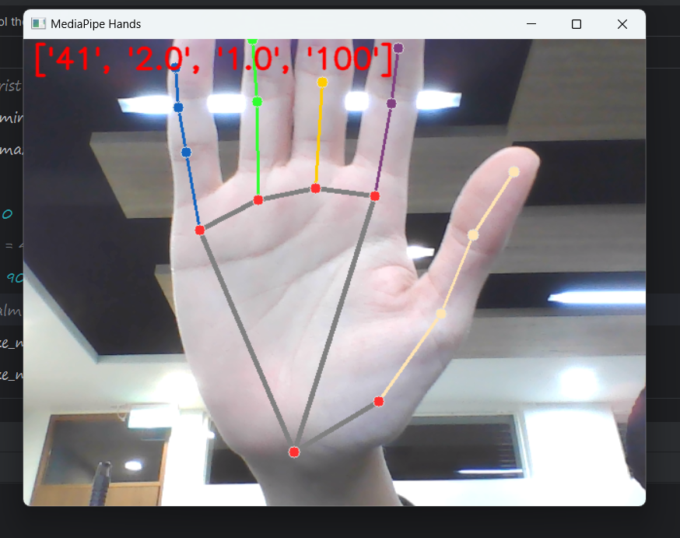

Fig. 14. Lower boundary for z-axis

### End-effector

We perform distance calculations between the wrist and each index finger, establishing a threshold to discern whether the hand is clenched in a fist. If the determined condition signifies a fist, the gripper is subsequently engaged for grasping.

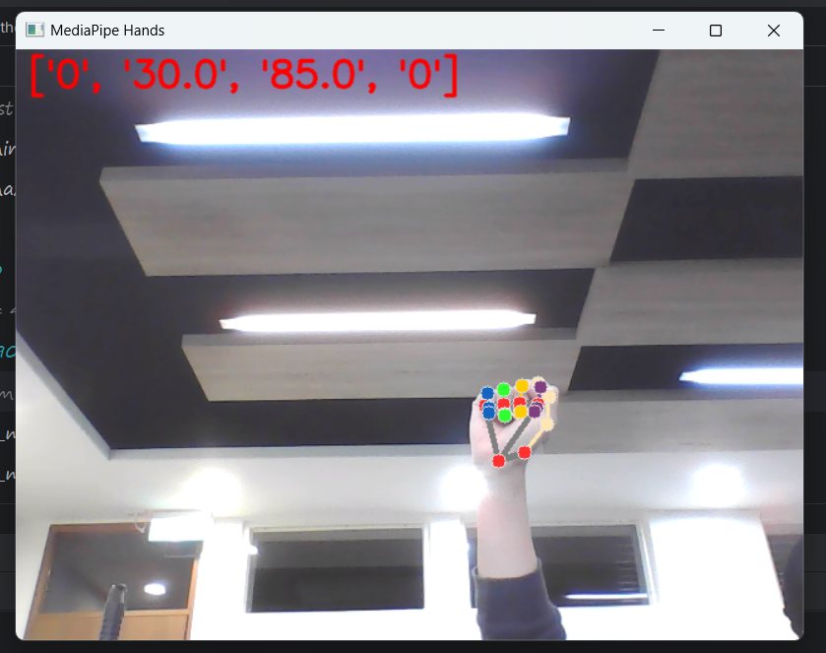

Fig. 14. Lower boundary for z-axis

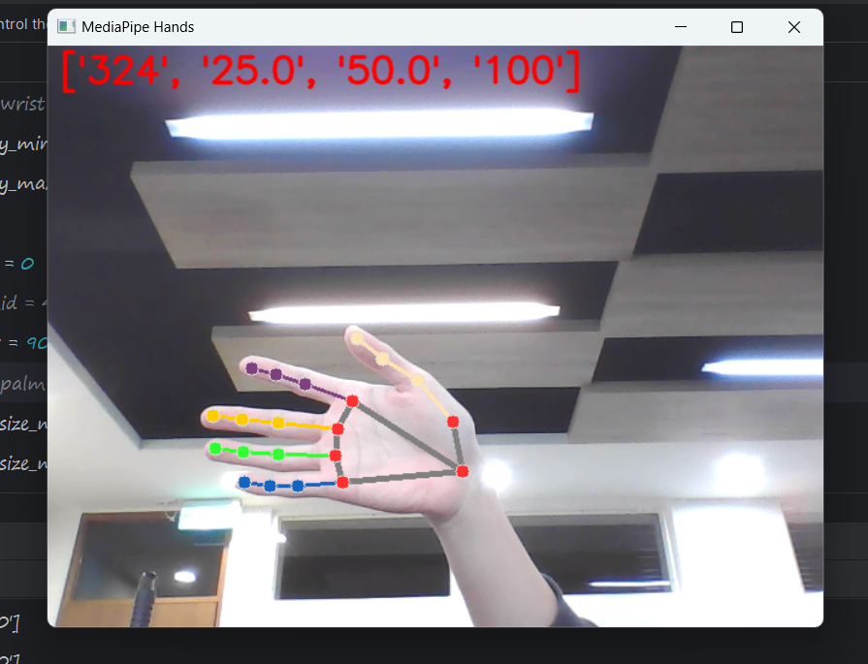

Fig. 9. Upper boundary for x-

# Discussion

The control of robotic arms can be achieved through either relying on hardware components and employing professional controllers or wearable gloves with flexible sensors. However, a drawback of these hardware controls is their cost and the need for sophisticated sensor technology and equipment.

Moreover, building up the dataset, and training the model to recognize hand gestures. However, collecting the various kinds of hand gestures, labeling them, and training with deep learning models is quite time-consuming as well as complicated. Thus, replacing what the above mentioned with hand gesture recognition through computer vision, could reduce the cost and complexity of hardware making and be widely applied in various kinds of things related to facility controlling as well. And also, we replace the traditional method with Media Pipe, which offers real-time hand tracking and is essential for ensuring the robotic arm's immediate response to user gestures. These models bring the advantage of minimal computation time for highly robust and accurate hand tracking. In addition to applying hand gesture recognition to control the robotic arm, in the future, we can make the communication between Arduino and computer vision become wireless to control the robot without the distance limitation and integrate the 5G internet into it so that the speed of communication becomes faster. Our research will be probably applied to make the bomb disposal robot, the bomb disposal expert won’t dispose of the bomb in person. He merely stays in the safe and remote region which is extremely far from the bomb and controls the robotic arm carried by a self-propelled vehicle through two hands gesture recognition and 5G internet. How the robotic arm moves and works simultaneously corresponds to the motion and orientation of two hands so that it’s just as if the expert was disposing of the bomb in person. Thus, it makes the mission less hazardous and protects experts from getting injured.

# References

[1] E. Solly and A. Aldabbagh, “Gesture Controlled Mobile Robot,” in *2023 5th International Congress on Human-Computer Interaction, Optimization and Robotic Applications (HORA)*, Istanbul, Turkiye: IEEE, Jun. 2023, pp. 1–6. Accessed: Oct. 24, 2023. [Online]. Available: https://ieeexplore.ieee.org/document/10156800/

[2] W.-T. Weng, H.-P. Huang, and Y.-L. Zhao, “The Application of Dual-arm Mobile Robot Systems in the Care of the Older Adults,” in *2022 International Conference on System Science and Engineering (ICSSE)*, Taichung, Taiwan: IEEE, May 2022, pp. 127–132. Accessed: Oct. 24, 2023. [Online]. Available: https://ieeexplore.ieee.org/document/9948250/

[3] M. Al-Hammadi *et al.*, “Deep Learning-Based Approach for Sign Language Gesture Recognition With Efficient Hand Gesture Representation,” *IEEE Access*, vol. 8, pp. 192527–192542, 2020

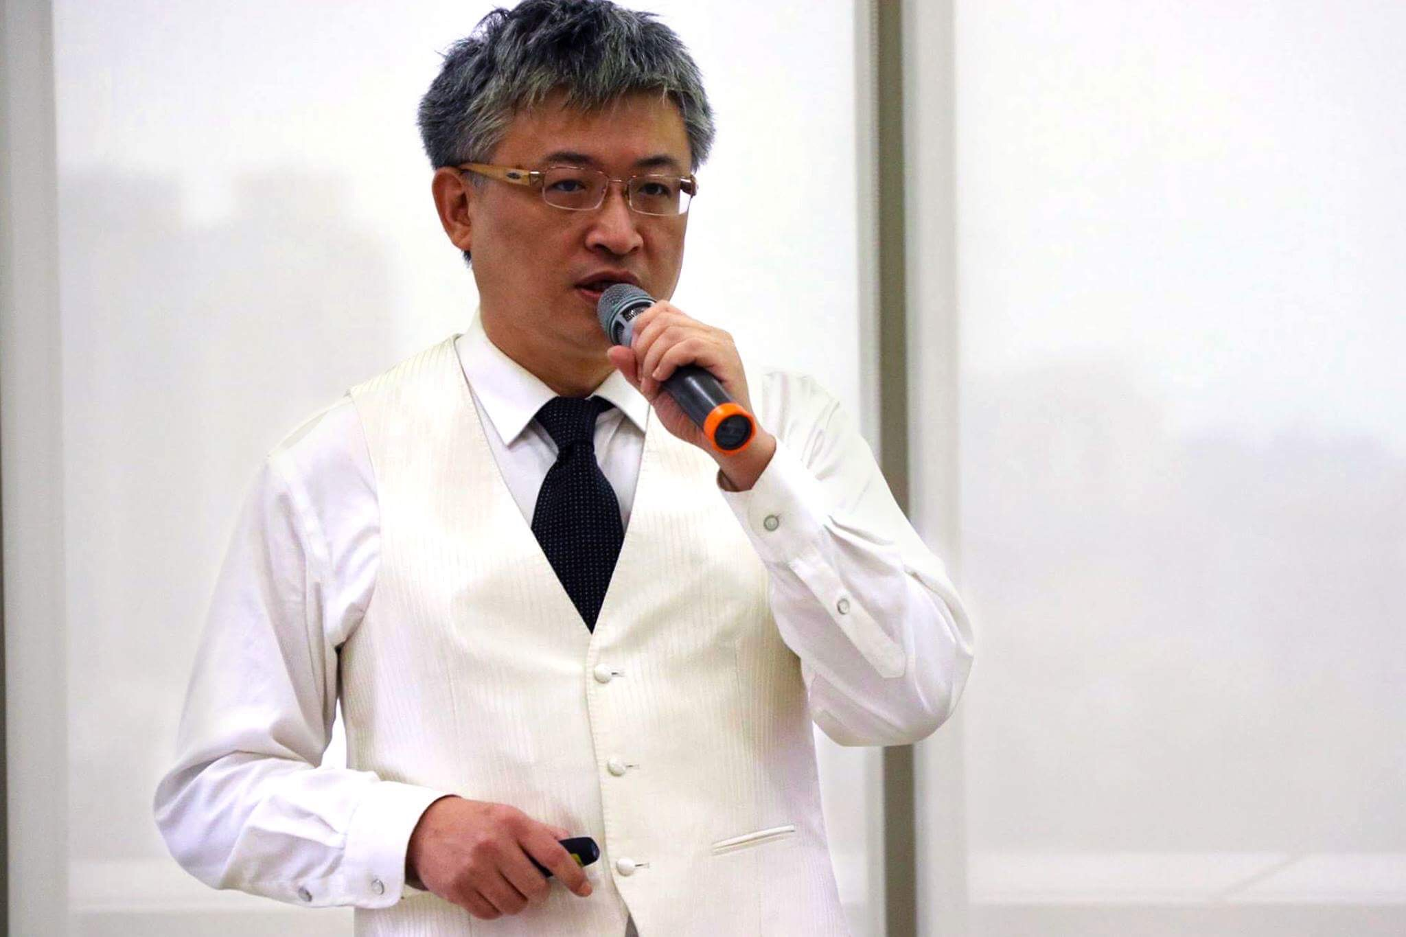**Min-Fan Ricky Lee** received his Bachelor degree from Tam Kang University, Republic of China (Taiwan) in 1988. He received his Ph.D. and Master degree from Cornell University, USA in 1996 and 1991 respectively. He is currently the Associate Professor at the Graduate Institute of Automation and Control, National Taiwan University of Science and Technology, Republic of China (Taiwan).

He was the Research Officer at the National Research Council in the Federal Government of Canada from 1998 to 2007 and the Research Scientist at the Department of Mechanical Engineering at the University of British Columbia, Canada from 1996 to 1998. He was the Mechanical Engineer at the Engineering Maintenance and Repair Division in Flight Command of the Army, Republic of China (Taiwan) from 1988 to 1990.

He served as the Past Chair, Chair, Vice Chair, Treasurer, and Secretary of the IEEE Vancouver Section from 1998-2003.

His research areas are Robot and Artificial Intelligence. His Ph.D. dissertation, “An Intelligent Computer Vision Control and Target Tracking System Design of an Agricultural Grapevine Pruning Robot”, received the National Design Gold Award USA. He received the Outstanding Service Award from IEEE Canada. He was endowed the title of “International Taiwan Youth Ambassador” by the President of the Republic of China (Taiwan) on September 30, 2011.

**Hugo Pinard** began at the Lycée Pilote International Innovant from 2017 to 2019. Subsequently, he pursued an integrated preparatory program at the University of Technology of Troyes. In 2021, Hugo had the opportunity to study Computer Science for a semester at the Universitatea Tehnică din Cluj-Napoca in Romania. Following this experience, he specialized in Industrial Engineering, focusing on continuous improvement, data management, and supply chain. Currently, Hugo is on an academic exchange at NTUST in Taipei, Taiwan, and he is about to embark on an internship at Louis Vuitton as a Central Distributor, where he eagerly anticipates applying his skills and knowledge.

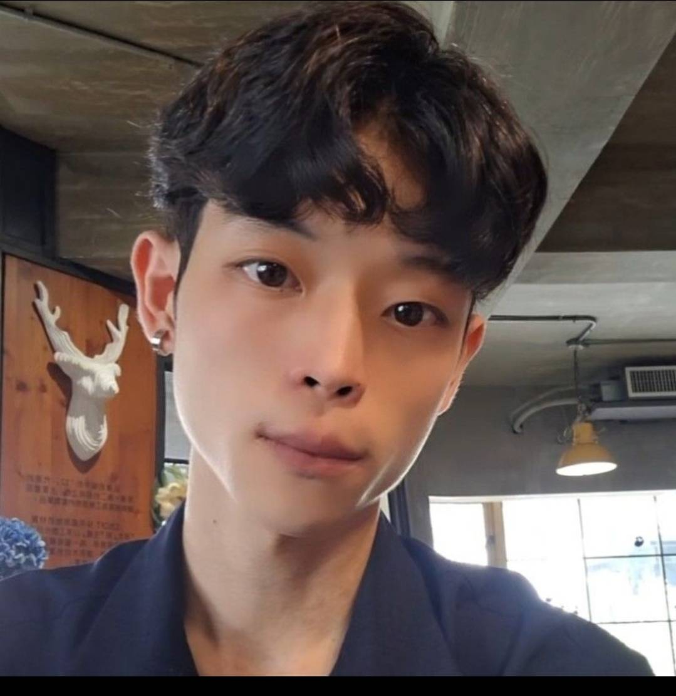**T**s**ung-Ching Yang** graduated from national taipei University of technology in department of electrical engineering.And currently,he study in graduate institute of Automation and Control in NTUST.

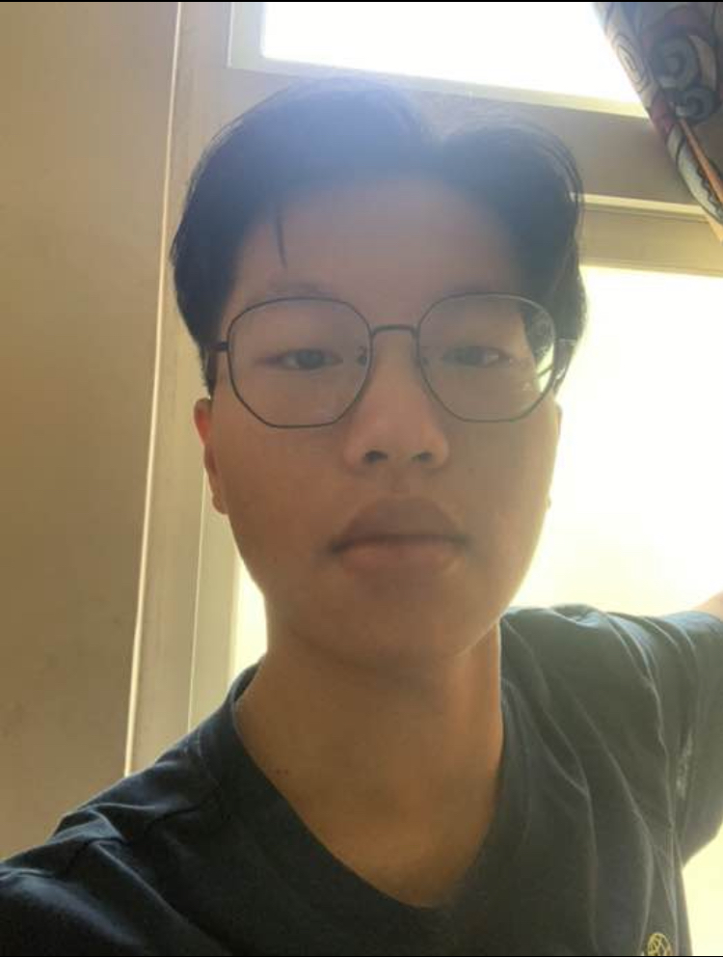**Yi-Hung Chuang** received is BatchelorDegree from the Mechanical Engineering in Tam kang university, Republic of China in 2023. He pursued a master’s degree in Institute of Automation and Control in National Taiwan University of Science and Technology in 2023.

**Peter Rubatscher i**s currently pursuing his Master’s in Artificial Intelligence at JKU Linz and is studying abroad at NTUST Taipei. He earned Bachelor’s degrees in both AI and Physics from JKU Linz in 2023. Notably, he studied abroad at UCT Cape Town in 2022.